CORREX Auto Implementations Site – 2014/Jul Changes

Contents

Directions 2

Concur 2

AEGBT 2

Offline Form 2

Setup Information 2

# Directions

## Concur

Please provide a sizing before making any site changes. Once sizing is approved, changes should be made to the Developer site first, to allow AEGBT opportunity to review, test, and accept the changes prior to going into production.

## AEGBT

Fill in the sections of this document corresponding to the site functions which require change. Include screen shots or mock-ups of each item if possible. Before submitting to Concur, delete the sections that do not apply (no changes). Then update the table of contents. Include the year and month in the document title (page 1) as well as the saved file name.

# Offline Form

## Setup Information

**Branch Number** currently permits entry of a maximum of 4-digit number. This needs to be increased to a maximum of a 5-digit number. The minimum length of data is a 1-digit number as previously. This field does not currently automatically pad the leading zeros to get to a minimum of 4 digits, can we please add this function?



Must permit 1-5 digits. Should pad with leading zeros up to 4 digits if <4.

Figure : Branch number

**Additional Branch Number(s)** currently permits entry of a maximum of 4-digit number (when not using comma separated list). This needs to be increased to a maximum of a 5-digit number. The minimum length of data is a 1-digit number as previously. Branch numbers less than 4 digits in length should be padded with leading zeros to make a minimum of 4 digits in length as previously.

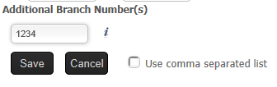

Must permit 1-5 digits. Leading zeros up to 4 digits if <4.

Figure : Additional Branch number (single)

**Additional Branch Number(s) Help Text** must be adjusted to say: “Branch Code must be 4-5 numeric characters, if not system will add leading zeros up to 4.”

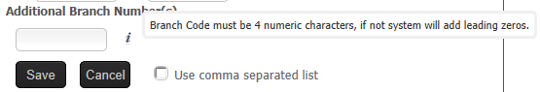

Help text

Figure : Additional Branch number help text

**Additional Branch Number(s) – Comma separated list** currently only permits the values between the commas to be between 1-4 digit numbers. This must be expanded to permit 1-5 digit numbers.

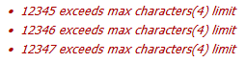

Figure : Additional Branch number warning text

**Additional Branch Number(s) – Maximum number of entries** currently the field permits a maximum of 7 additional entries. In truth, the limit is not the number of branches, but the limit of a CORREX lookup table of 40 total characters including delimiters. Now that the branch number length is variable between 4-5 characters with leading zeros, we need to make this limit more flexible. Can we calculate: Total Length = Length of Branch number (primary, including the leading zeros) + Grand Total Length of all Additional Branch Numbers (including leading zeros) + Number of Additional Branch Numbers (to allow for the delimiters that must be part of the table). If Total Length thus calculated exceeds 40, prohibit the entry and show a warning. Also the text of the warning should be changed to: “**Branch Numbers Exceed Maximum Limit (40 characters)”

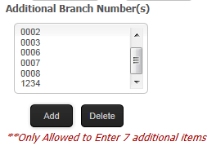

Maximum additional branch numbers is not fixed 7, but could be between 5-7 depending upon length

Warning text needs to change

Figure : Additional Branch numbers maximum warning

Examples:

|  |  |  |  |  |
| --- | --- | --- | --- | --- |
|  | **Example 1 (valid)** | **Example 2 (valid)** | **Example 3 (valid)** | **Example 4 (too long)** |
| *Primary branch number* | 0001 | 12345 | 12345 | 12345 |
| *Additional branches* | 0002  0003  0004  0005  0006  0007  0008 | 12346  12347  12348  12349  12340 | 0002  12346  0003  12347  0004  12348 | 12346  12347  12348  12349  12340  12341 |
| *Calculated length* | 39 | 35 | 38 | 41 |
| *Result* | OK save | OK save | OK save | Display warning text and do not allow most recent entry |